Mean, Median, and mode (measures of central tendency) can be a good indicator for a set of data but it does not completely describe the data. Compare set A and Set B below:

|  |  |
| --- | --- |
| Test Scores A | Test Scores B |
| 95 | 71 |
| 90 | 70 |
| 85 | 69 |
| 80 | 68 |
| 75 | 67 |
| 70 | 66 |
| 65 | 65 |
| 60 | 64 |
| 55 | 63 |
| 50 | 62 |
| 45 | 61 |
| 40 | 60 |
| 35 | 59 |
| Mean: 65 | Mean: 65 |
| Median: 65 | Median: 65 |

Set A and Set B have the same mean or average test score of 65. Their median is also the same. But each set reflects a different set of grades.

We should consider looking at the ___________________

or the “spread” of the data.

Two measures of dispersion are ____________________

and ____________________________________.

**I.** Range

___________________ looks at the difference from lowest to highest values.

**Range = (greatest value in data set) – (least value in data set)**

**EXAMPLE:** what is the mean, median, and range for the set of quiz grades for Max and Molly?

|  |  |  |
| --- | --- | --- |
| Quiz | Max | Molly |
| 1 | 28 | 27 |
| 2 | 22 | 27 |
| 3 | 21 | 28 |
| 4 | 26 | 6 |
| 5 | 18 | 27 |
| Mean: |  |  |
| Median: |  |  |
| Range: |  |  |

Who is the more consistent quiz taker? Why?

Look at the range.

_____________________________________________

_____________________________________________

_____________________________________________

**II.** Standard Deviation

____________________________________ is based on deviations from the mean of a set of data values.

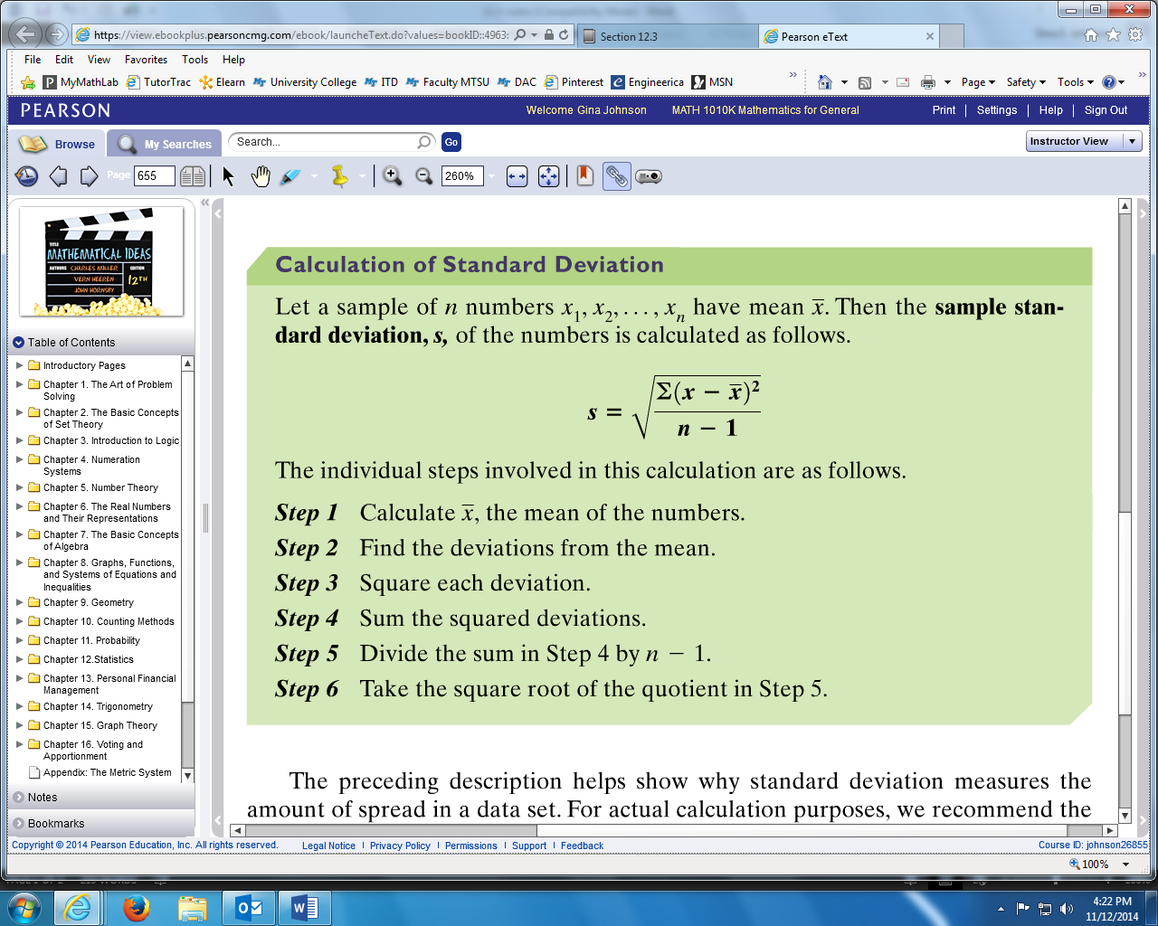

**EXAMPLE:** Find the standard deviation of the following sample using the step-by-step process above.

**32, 41, 47, 53, 57**

Step 1: Calculate the mean.

Step 2: Find the deviations from the mean. (data value minus the mean)

|  |  |  |  |  |  |
| --- | --- | --- | --- | --- | --- |
| Value | 32 | 41 | 47 | 53 | 57 |
| Deviation |  |  |  |  |  |

Step 3: Square each deviation.

|  |  |  |  |  |  |
| --- | --- | --- | --- | --- | --- |
| Value | 32 | 41 | 47 | 53 | 57 |
| Deviation2 |  |  |  |  |  |

Step 4: Sum the squared deviations.

Step 5: Divide that sum from step 4 by .

Step 6: Square root the quotient from step 5.

**EXAMPLE:** Using your calculator, find the standard deviation for the sample.

7, 9, 18, 22, 27, 29, 32, 40

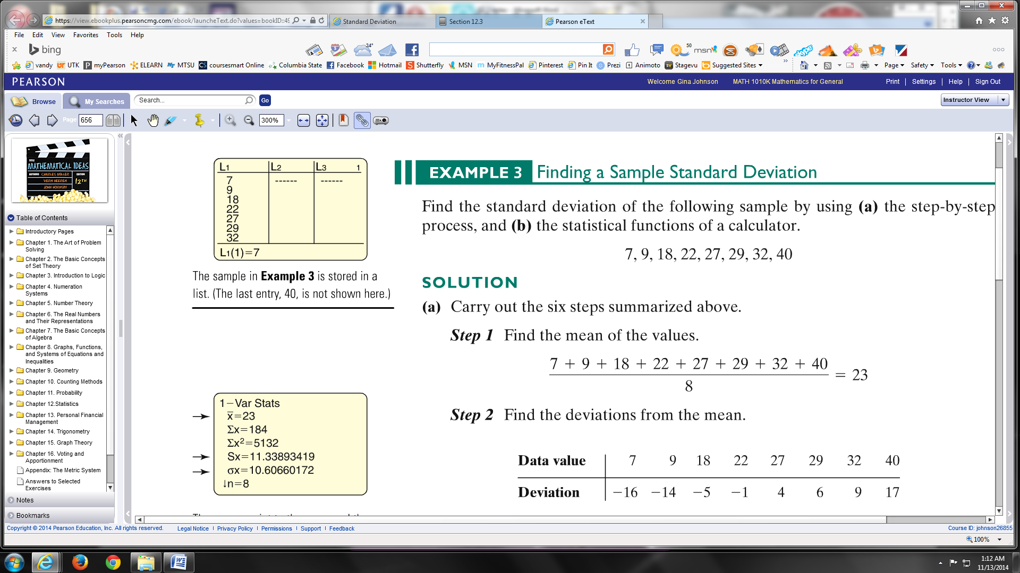

STAT

EDIT

1:EDIT

Type numbers in L1 (list one)



STAT

CALC

1: 1 – VAR STATS (one variable statistics)

ENTER (the calculator will default to L1)

_____________________________________________

____________________________________________

____________________________________________

Sx ____________________________________________

_____________________________________________

**EXAMPLE:** Using your calculator, find the standard deviation for the sample.

**32, 41, 47, 53, 57**

*Sx* = _________

**III.** Chebyshev’s Theorem

Chebyshev was a Russian mathematician (1821-1894) who helped develop an inequality that states what percent of the data values is within a specific standard deviation no matter what their distributions are like, no matter if the sample size is too small or large enough.

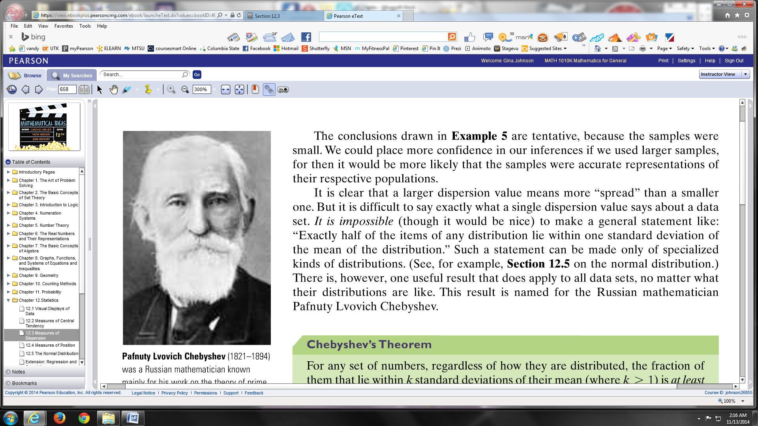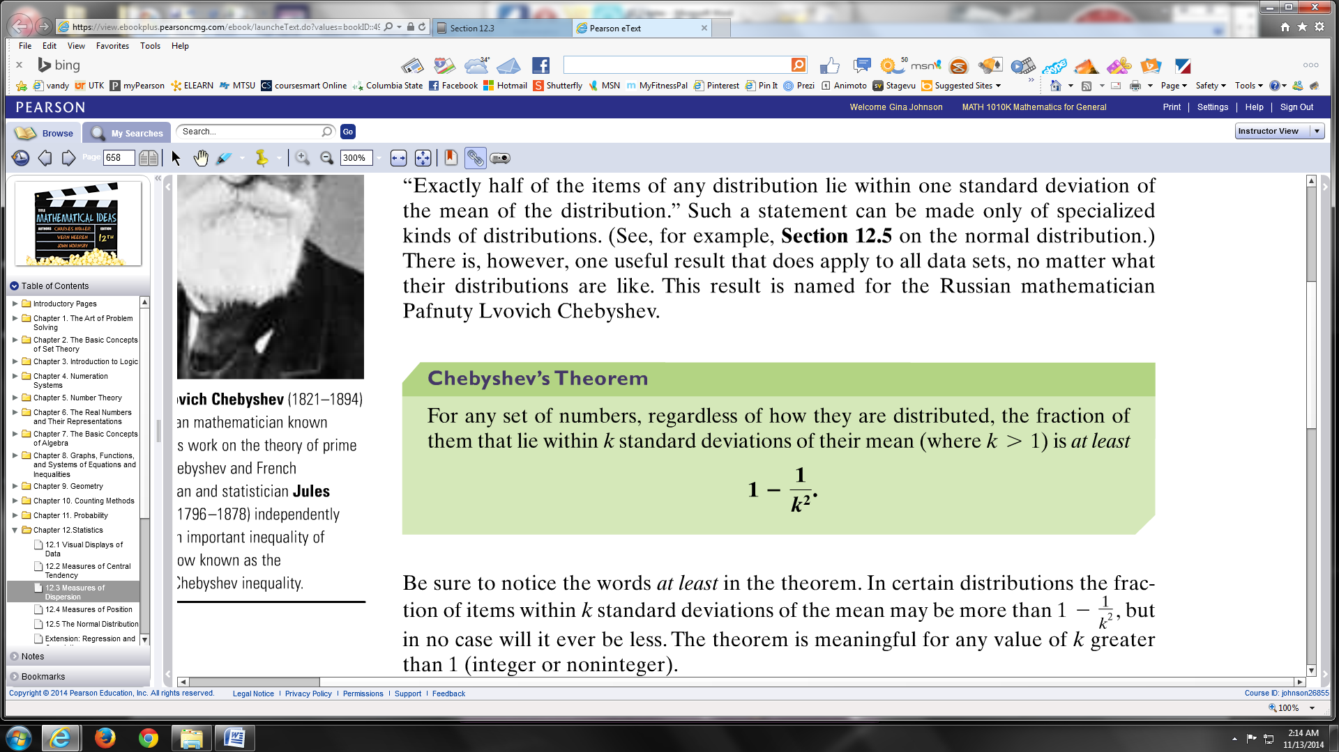

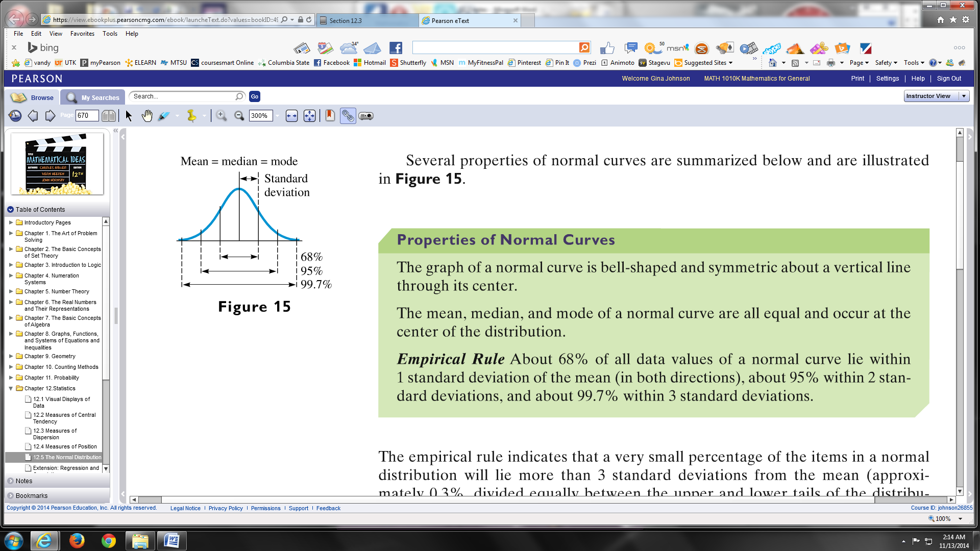



**EXAMPLE:** What is the minimum percentage of the items in a data set that lie within

3 standard deviations?

k = 3

**EXAMPLE:** In a distribution of numbers, the mean is 80 and the standard deviation is 8. At least what fraction or percent are between the following two numbers?

1. 64 and 96

2. 48 and 112